Read the *entire* instructions before you try to follow them. Knowing where you are going will help.

It helps to have the Formatting Reference and the Style Reference documentation as you move through this workflow.

First, **Show Hidden Characters** (ctrl+alt+i) and the **Highlight Override** feature ([a] at the top of the Paragraph Style menu). Don’t do anything before turning these on.

# Initial Styling and Alignment

**If the prose text has chapters, start with the first discrete section. This is often Chapter 1, but may be a Prologue. You will want to complete the Initial Styling and Alignment, Tagging First Steps, and Semantic Tagging steps in their entirety in a chapter before inserting the next chapter.** Since InDesign gets touchy the more you edit text frames, especially with prose, it's best to have everything finished before inserting the next chapter.

## Incipits, Rubrics, and Explicits

First, check the beginning for **Incipits** and **Rubrics**, or chapter headings.

* These are **Paragraph Styles** that should be re-styled before you do further formatting.
* If these are present, you need to tag them using **Prose Incipit** or **Prose Rubric**, found under the Prose Template folder in the Paragraph Styles menu.

Next, check the end for **Explicits**.

* This is also a **Paragraph Style** that should be re-styled before you do further formatting.
* If present, you need to tag them using **Prose Explicit**, found under the Prose Template folder in the Paragraph Styles menu.

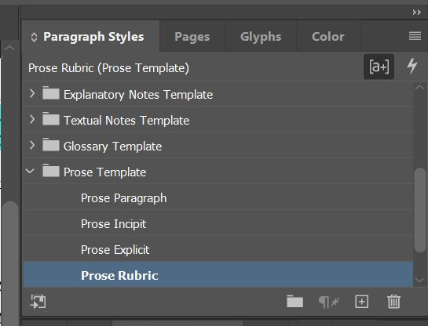

## Broad Style Adjustments

Double check that the **Footnote** **Paragraph Style** and the **Footnote Number Character Style** have been correctly applied. These settings should already be set from following the Initial Steps for All InDesign Documents workflow, but double check that it applied correctly.

* If they are not set, go back to the Document Footnote Options section of the Initial Steps workflow

Next, go back to the beginning of the Text and clear all overrides. You can’t tell if the text is formatted correctly until you clear overrides, and you do not want to format 5,000 lines only to discover that when you remove the override you actually have more formatting to do.

* Set the first paragraph of the chapter (that is not an Incipit or a Rubric) as **Prose Paragraph** Paragraph Style, if you have not already done so through Style Mapping.
* Clear overrides. Refer to the Formatting Reference (section Overrides) for additional information about overrides.

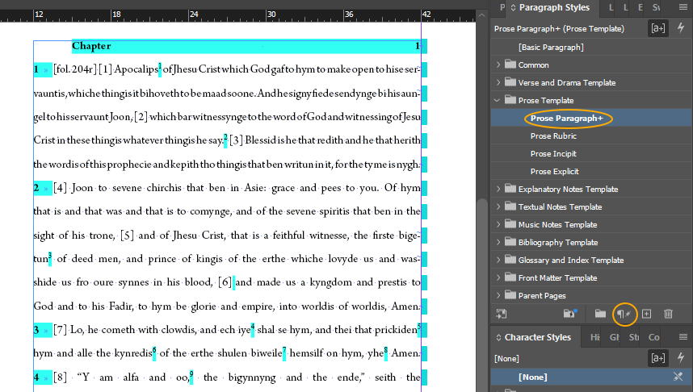

This should make all of the text the correct font and, for **Prose Paragraph**, add in the necessary tab at the beginning of text blocks. Unfortunately, it also removes things like italics, but you’re going to correct this later.

## Alignment Correction

* In your first formatting run-through, you should only look for alignment issues. Work paragraph-by-paragraph, looking for the following:
  + Make sure that there are no tabs at the beginning of paragraphs.
  + Delete any paragraph numbers from the beginning of paragraphs. Don’t worry; we’ll add these back to the document as the last step.

## Adding formatting back into the **Text**:

* Because you deleted all the special font characteristics when you deleted the override, you now need to add those back in before you can move on to more advanced tagging. Going paragraph-by-paragraph with the original document open next to your InDesign Document, you will tag the following **Character Styles**:
  + Language tags (see Style Reference, section Character Styles – Languages, for full list, especially for French)
  + **Title** (this is very rare).
  + Any other formatting that is covered by pure formatting tags with no semantic meaning (see the section Character Styles – Formatting Only in the Style Reference)
  + Check **em-dashes** (between clauses) and **en-dashes** (between number ranges) for correctness (see Formatting Reference, sections Em-dash and En-dash, for full instructions)

This is a sample of what a chapter of a prose text should look like before you move on to **Tagging, First Steps**. Note the following:

* The first line of the chapter (in this case, the Rubric) begins at the top of the text frame, indicated by the blue line.
* The text frame does not stretch all the way across the page; instead, it leaves some room to the left of the text. This indicates you have applied the correct Parent Page.
* The chapter rubric has had **Prose Rubric** Paragraph Style applied, and the paragraph has had the **Prose Paragraph** Paragraph Style applied.
* Footnotes have the **Footnote** Paragraph Style applied, but the **Footnote Gloss** Character Style has not been applied yet.

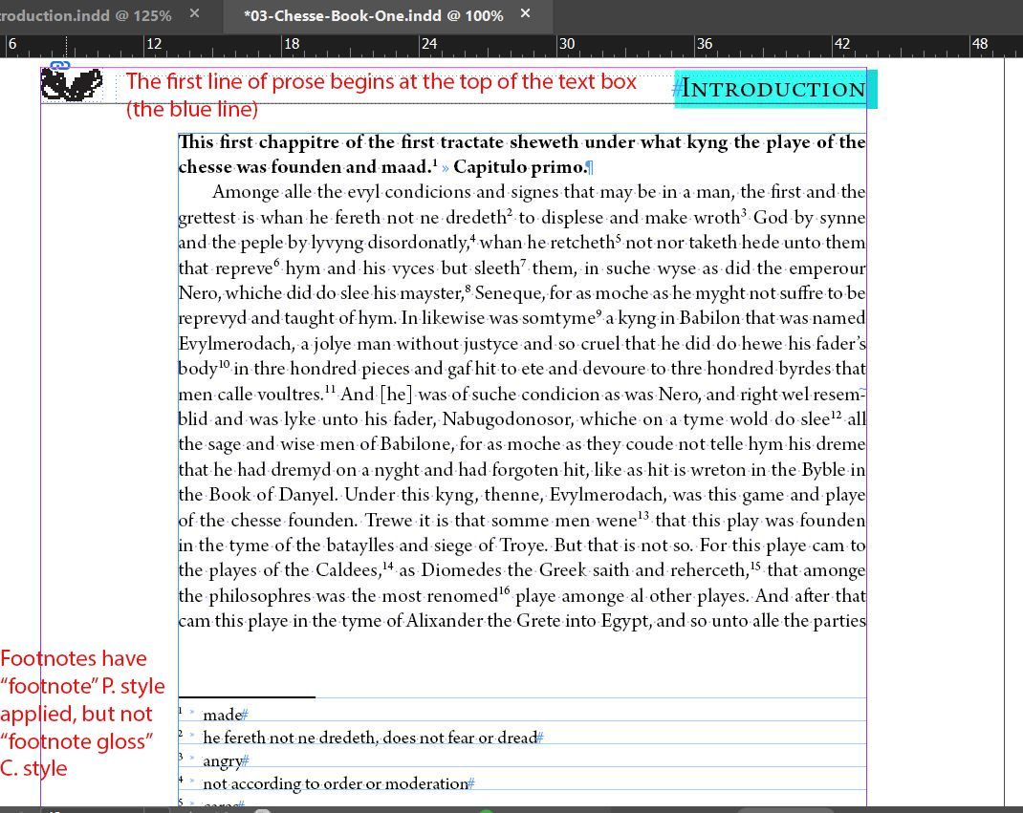

* You are now ready to move on to **Tagging, First Steps**

# Tagging Texts, First Steps

This round requires great attention to detail. This is why it is its own step.

## Round One: Foliation

* Tag **Foliation** [fol. 6r]
  + In prose, any folio numbers will be embedded in the text. If you are having trouble scanning the prose for folio numbers, it can help to search for the phrase ‘[fol.’ to help locate these instances.
  + Select the entire phrase, including brackets, and apply the **Foliation** Character Style.

## Round Two: Footnotes

You will want to delete any extra spaces at the beginning of the footnotes, or at the end of the gloss in a footnote. There should not be any spaces in between the tab and the start of the footnote, nor any spaces at the end of the gloss. You can check this manually, but it is recommended that you use the Find / Change function in InDesign. Refer to the guidelines in the Formatting Reference documentation (section Footnotes spacing)

Unfortunately, you will have to look for and delete spaces at the end of footnote glosses manually.

After fixing the aligning, you will need to check for the following:

* Delete any periods at the end of the glosses unless the gloss is a full sentence.
* If the footnote is glossing two or more Middle English words, there should be a catchphrase followed by a comma at the beginning of the footnote
  + If the catchphrase normally italicized in the text (either because it is in a foreign language such as Latin or is a title), we do not replicate those italics in the catchphrase.
* Apply **Footnote Gloss** Character Style to any information that is providing direct elucidation of the original language phrase in question. This includes
  + Any direct translations provided by the editor
  + Any language designations that indicate whether a word comes from a particular language like Latin or Old French
  + Scripture references if the line being glossed is a paraphrase or a restatement of a particular Bible verse
    - These may be applied on a case-by-case basis evaluation to see if the reference is helping explain the gloss or if the editor is providing extra explanatory note context in the footnote.
* We do not apply **Footnote Gloss** Character Style to the following:
  + Any catchphrases in the original language and the comma that follows them
  + See note or See t-note parenthetical phrases that follow any glosses
* For example: Footnotes 1 and 3 only include the provided gloss, which have **Footnote Gloss** Character Style applied. Footnote 2 includes a catchphrase in Latin, a gloss, and a (see note) parenthetical phrase. Only the gloss phrase “Now you dismiss” has **Footnote Gloss** Character Style applied.

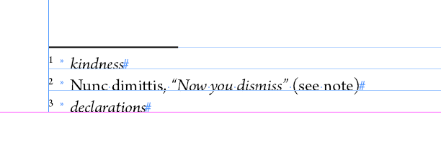

* Clear overrides. Refer to the Formatting Reference (section Overrides) for additional information about overrides.

This is a sample of what a chapter of a prose text should look like after you complete **Tagging, First Steps / prior to Semantic Tagging. Note the following:**

* The folio number phrase [fol. 71v] has been tagged with **Foliation** Character Style.
* The **Footnote Gloss** Character Style has been applied only to the glosses, not to any catchphrases, punctuation, or extra explanatory information.

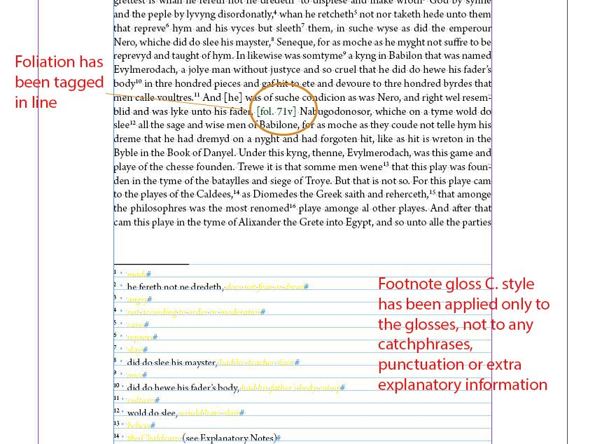

**Move on to Semantic Tagging**

# Semantic Tagging

This step is much more time-consuming and requires that you read the text for meaning. Do not use **ctrl+f** for this work; see the Formatting Reference (section Don’t use Ctrl+F to tag repeated names or places!) if you have questions.

We complete semantic tagging for any files we consider a main Text within an edition. We do not apply semantic tags in Appendix files, even if Appendix files have been edited for this edition and/or come with their own set of Textual Notes.

## Tag only the text, not the glosses in the footnotes.

Make sure to **tag all parts of the Text**; this includes Rubrics, Incipits, Explicits, etc. if they are **in the original language**. If these appear in **Modern English**, check the Introduction or the Textual Notes to make sure that they are editorial interventions and **do not tag**.

For this round, tag using the following Character Styles:

* **Animal Name**
* **Person Name**
* **Place**
* **Date**

## Keep Reference documents open while tagging.

The Style Reference document is where we have defined when and where we apply these Character Styles. It also contains examples of what to tag and what not to tag.

* There are section headings for each of the following tags:
  + Animal Name
  + Date
  + Person Name
  + Place

It also helps to refer to the Explanatory Notes files for the edition you are working on. In these notes, the editor(s) often give more context about important people, places, or dates mentioned by the text; if you are unsure whether a phrase is a Person Name or a Place name, check these Explanatory Notes to see what commentary the editor has included.

## Record any questions you have as queries in Asana.

Semantic tagging is interpretative work, and Middle English can be tricky. It’s normal to have questions about what is happening in a text and whether a particular word should be tagged (especially when it comes to questions of heaven and hell). Do the best you can, and also record the questions that you have as subtasks nested under the relevant formatting task in Asana. For full guidelines on how to record queries in Asana, see the Queries in Asana documentation.

## Nested Tagging

You may run into issues with nested tagging, where you need to apply more than one Character Style to the same bit of text (i.e., when the text inserts a Middle French phrase that also contains a person name). It’s not possible to apply more than one Character Style at a time in InDesign, so we need to document any instances in the edition’s oXygen Interventions spreadsheet.

* Refer to the Formatting Reference (section Nested Tagging) for more instances of nested tagging.
* For how to fill in the oXygen Interventions spreadsheet, go to the Best Practices – oXygen Interventions documentation

# Inserting Any Following Chapters

First, make sure that the hashtag that indicates the end of the text appears after the final punctuation in the text frame of the chapter you just formatted. See Formatting Reference (section Completing a Text Frame) for more details.

If the prose text has multiple chapters, you will need to create new text frames to insert them into below existing chapters. You want to make sure that any new text frames created stand alone and are not threaded to previous chapters.

To be sure that your text frames are threaded correctly, turn on Show Text Threads:

* View → Extras → Show Text Threads

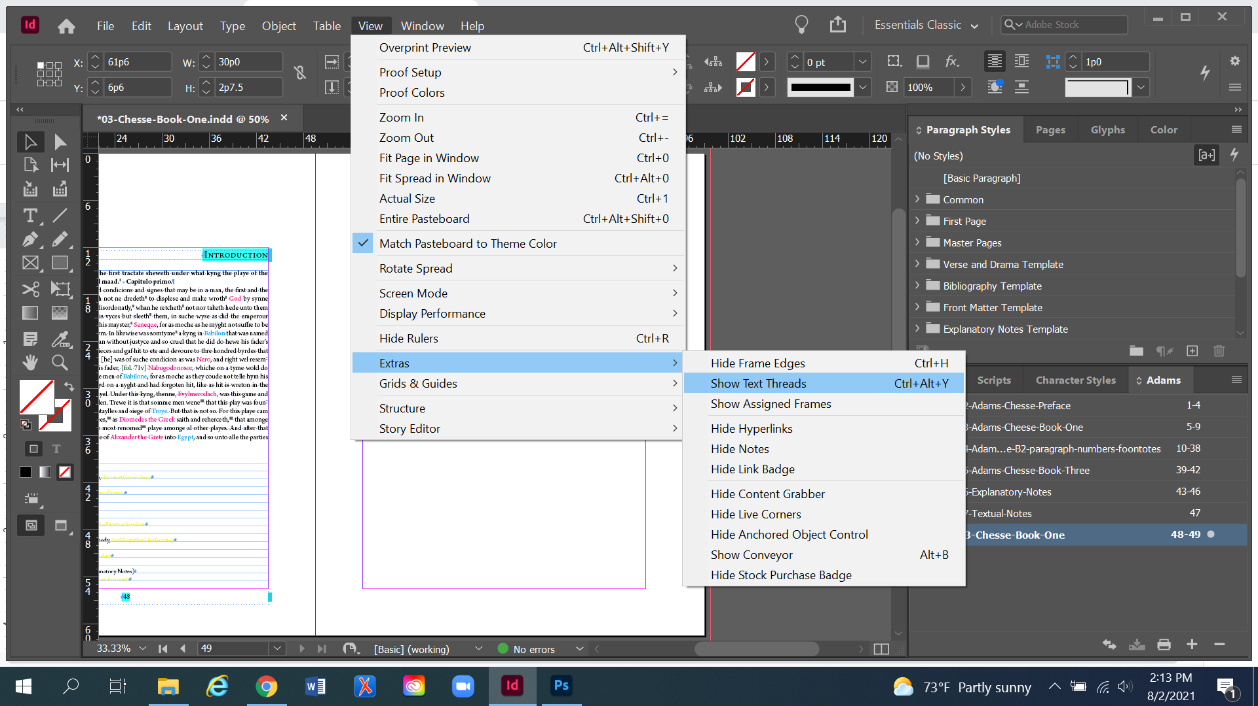

* After this setting is turned on, InDesign will show that frames have been threaded together by showing a blue line connecting the bottom of one frame to the top of the next frame. This thread only becomes visible if you are using the Selection Tool and have clicked onto a particular text frame.

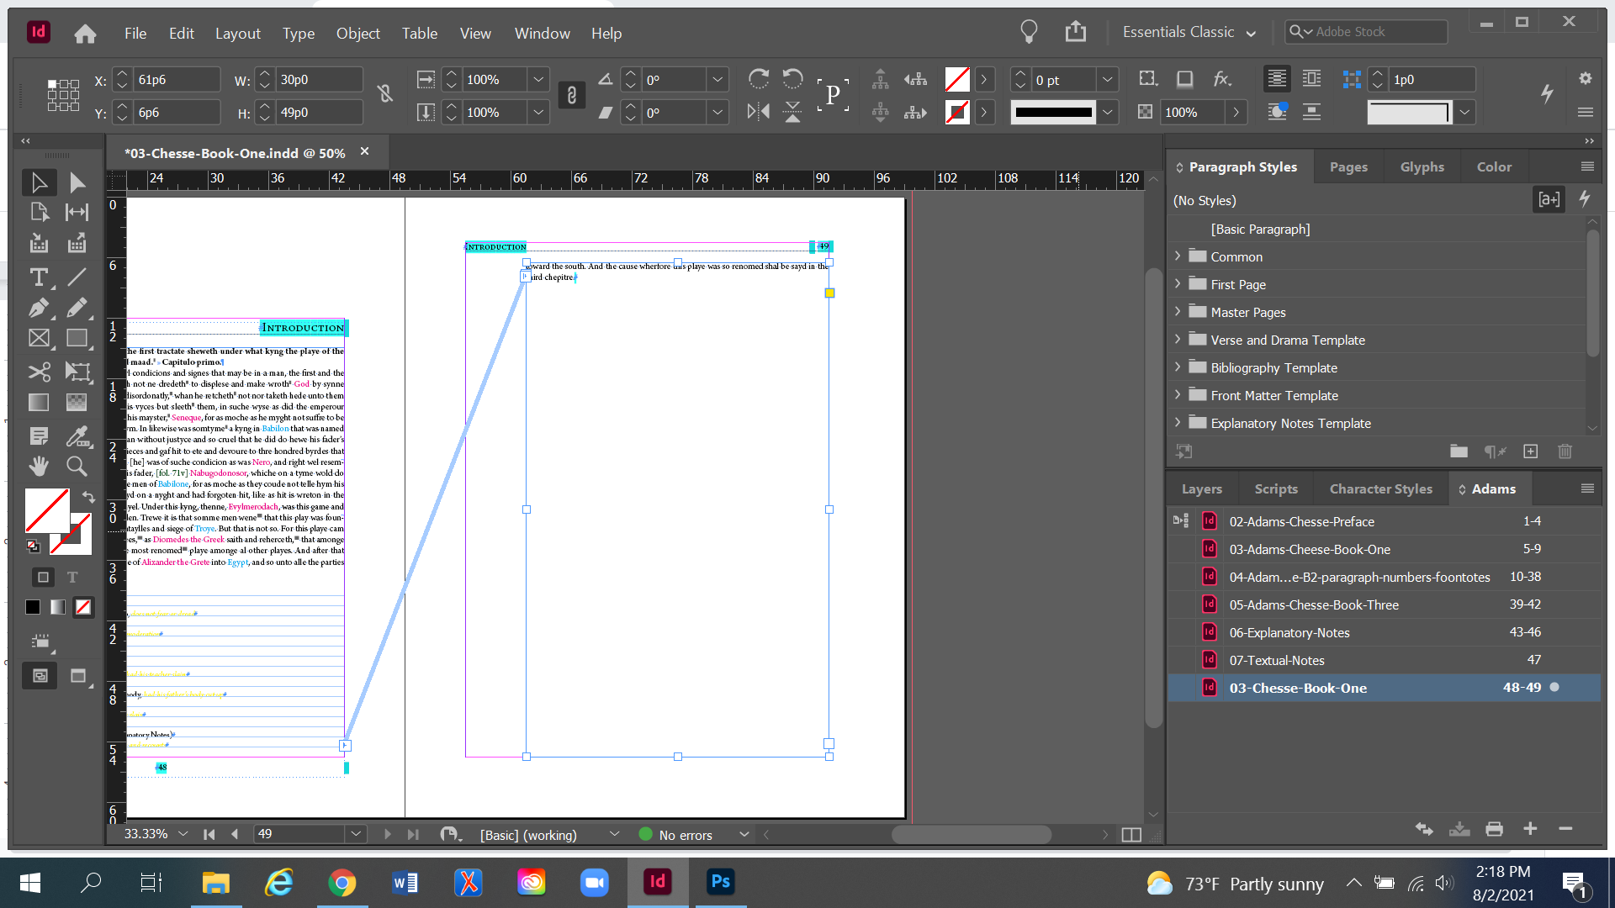

## Deciding Where to Insert a New Chapter

Where you insert a new chapter will depend on where the previous chapter has ended. The best way to see this is to adjust the size of the final text frame of the previous chapter and see where it lands on the page.

To adjust the size of the text frame, make sure you are using the Selection Tool and click on the final text frame of a chapter. Then, Right click > Fitting > Fit Frame to Content. This will automatically adjust the size of the text frame to include all text (including footnotes) without any excess white space.

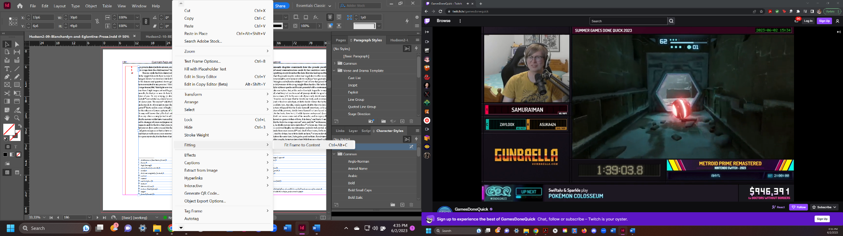

After you have resized the text frame, look at where the bottom of the text frame falls on the page.

* If it ends above 45p0 on the page’s ruler, you will want to insert the new chapter on the same page.
* If it ends near or after 45p0 on the page’s ruler, you’ll want to insert the new chapter on the next page.
* N.B.: If a text frame ends in the range of 45p0, it can be hard to tell whether there is room to start a new chapter on the same page or on a new page. If you are in doubt, then start the new chapter on a new page. Remember: These are guidelines, and it will take some time and experience setting chapters to get the feel of when there is room to start a chapter on the same page or a new page.

## Inserting a Chapter on the Same Page

Keep the resizing that you have done to the final text frame of the previous chapter.

Then, draw a new text frame underneath it using the Type Tool. The new text frame should take up the remainder of the page within the predetermined margins. Start drawing the new text frame at the bottom right corner of the margins. Stretch the text frame up until it matches the width of the previous text frame and the top of the frame you are drawing is flush with the bottom of the previous text frame.

* There will be green guidelines that appear when the text frame is the same width as another frame on the page. These green guidelines also appear when the sides of text frames are flush with each other. (See figure below.)
* This can be a finicky process. If it’s not right the first time you draw it, delete the text frame and try again.

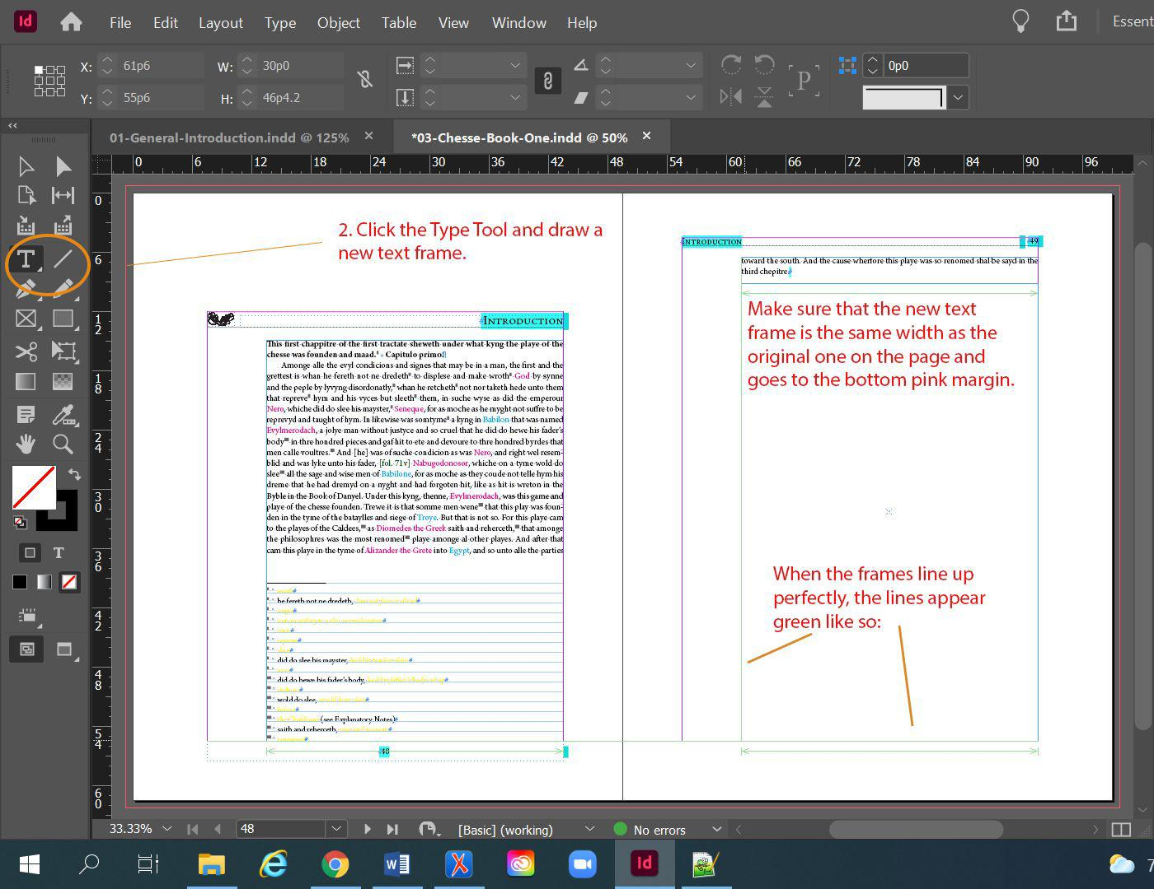

Next, you’ll want to set the Text Frame Spacing so there is a consistent amount of space between each chapter.

* Select the new text frame using the Selection Tool
* Right click > Text Frame Options > General
  + Inset Spacing: Make sure to break the link in the center of the inset spacing section. We don’t want all the spacings to be the same.
    - Set the Top to 3p0 spacing

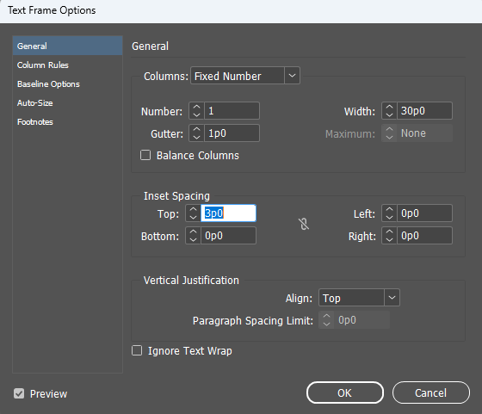

Once you’ve set the spacing, import the next chapter (Ctrl+D) into the text frame you have just created.

* See 03b. Making New InDesign Documents – Prose for a refresher on importing text from Word into InDesign

If your chapter is longer than the rest of that page, it won’t automatically flow onto a new page. Instead, you’ll need to add a new page.

* Go to the Pages menu and add a new Prose Body page to the end of your document
* In the InDesign Document, ctrl-shift-click inside the text frame on the new page. This will make a new text frame appear. You can tell because little squares appear in the lines at the edge of the text frame.
* Make sure you are using the selection tool (black arrow on left toolbar). Pick up the overset text by clicking on the red (+) on the bottom right of the first page. Hover your mouse over the new page. Notice that it seems to be holding the faint outline of text on it. Click into the box. This will insert the rest of the text into the new page and will cause the text to roll onto as many pages as your text requires.
* Then, return to the top of this workflow for Initial Styling and Alignment; Tagging, First Steps; and Semantic Tagging.

## Inserting a Chapter on a New Page

If you adjusted the size of the final text frame of the previous chapter in order to determine whether to place this chapter on a new page, please resize that text frame so it takes up the whole page again. Click off the text frame so that no text frame is selected.

Then, add a new page.

* Go to the Pages menu and add a new Prose Body page to the end of your document.
* In the InDesign Document, ctrl-shift-click inside the text frame on the new page. This will make a new text frame appear. You can tell because little squares appear in the lines at the edge of the text frame.
* Import the next chapter (Ctrl+D) into the text frame you have just created.
  + See 03b. Making New InDesign Documents – Prose for a refresher on importing text from Word into InDesign
* Then, return to the top of this workflow for Initial Styling and Alignment; Tagging, First Steps; and Semantic Tagging.

Repeat this process for all chapters in one InDesign document. **You need to have imported, formatted, and fully tagged all chapters in an InDesign document before inserting** **Paragraph Numbers**.

# Inserting Paragraph Numbers

You will be using the **LineNumbers4.1.1** plugin to insert paragraph numbers alongside each chapter. As of March 2025, this plugin is only installed on the three desktop workstations in the METS office: RCLMETS1-7460; RCLMETS3-7460-1; RCLMETS-7460-2.

Before you open the **LineNumbers plugin**:

* Use the Selection Tool to click into the first text frame of the chapter you need to apply paragraph numbers to.
* Make sure you have the Scripts panel and the Layers panel open.
  + Scripts panel: Window → Utilities → Scripts
  + Layers panel: Window → Layers

Open the **LineNumbers plugin** in the Scripts Panel:

* Click User > LineNumbers4.1 > LineNumbers4.1.1.

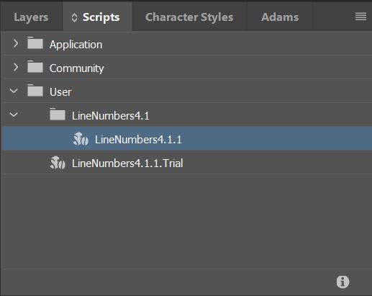

* We want **[Prose Template]Prose Paragraph** selected. This is what we care about mostly.
  + Deselect the Paragraph Styles **[Common]Footnote**, **[Prose Template]Prose Incipit**, **[Prose Template]Prose Explicit**, and **[Prose Template]Prose Rubric** by double clicking on them
  + Or, you can click the button Deselect All, then scroll and re-select **[Prose Template]Prose Paragraph** by double clicking on it
* Add Numbers to What? → This story only
* Numbering options:
  + Numbering Interval → 1
  + Placement → Left Margin
  + Uncheck → Restart numbering each page
  + Check → One number per paragraph only: Place numbers next to first line
* Click Add Numbers

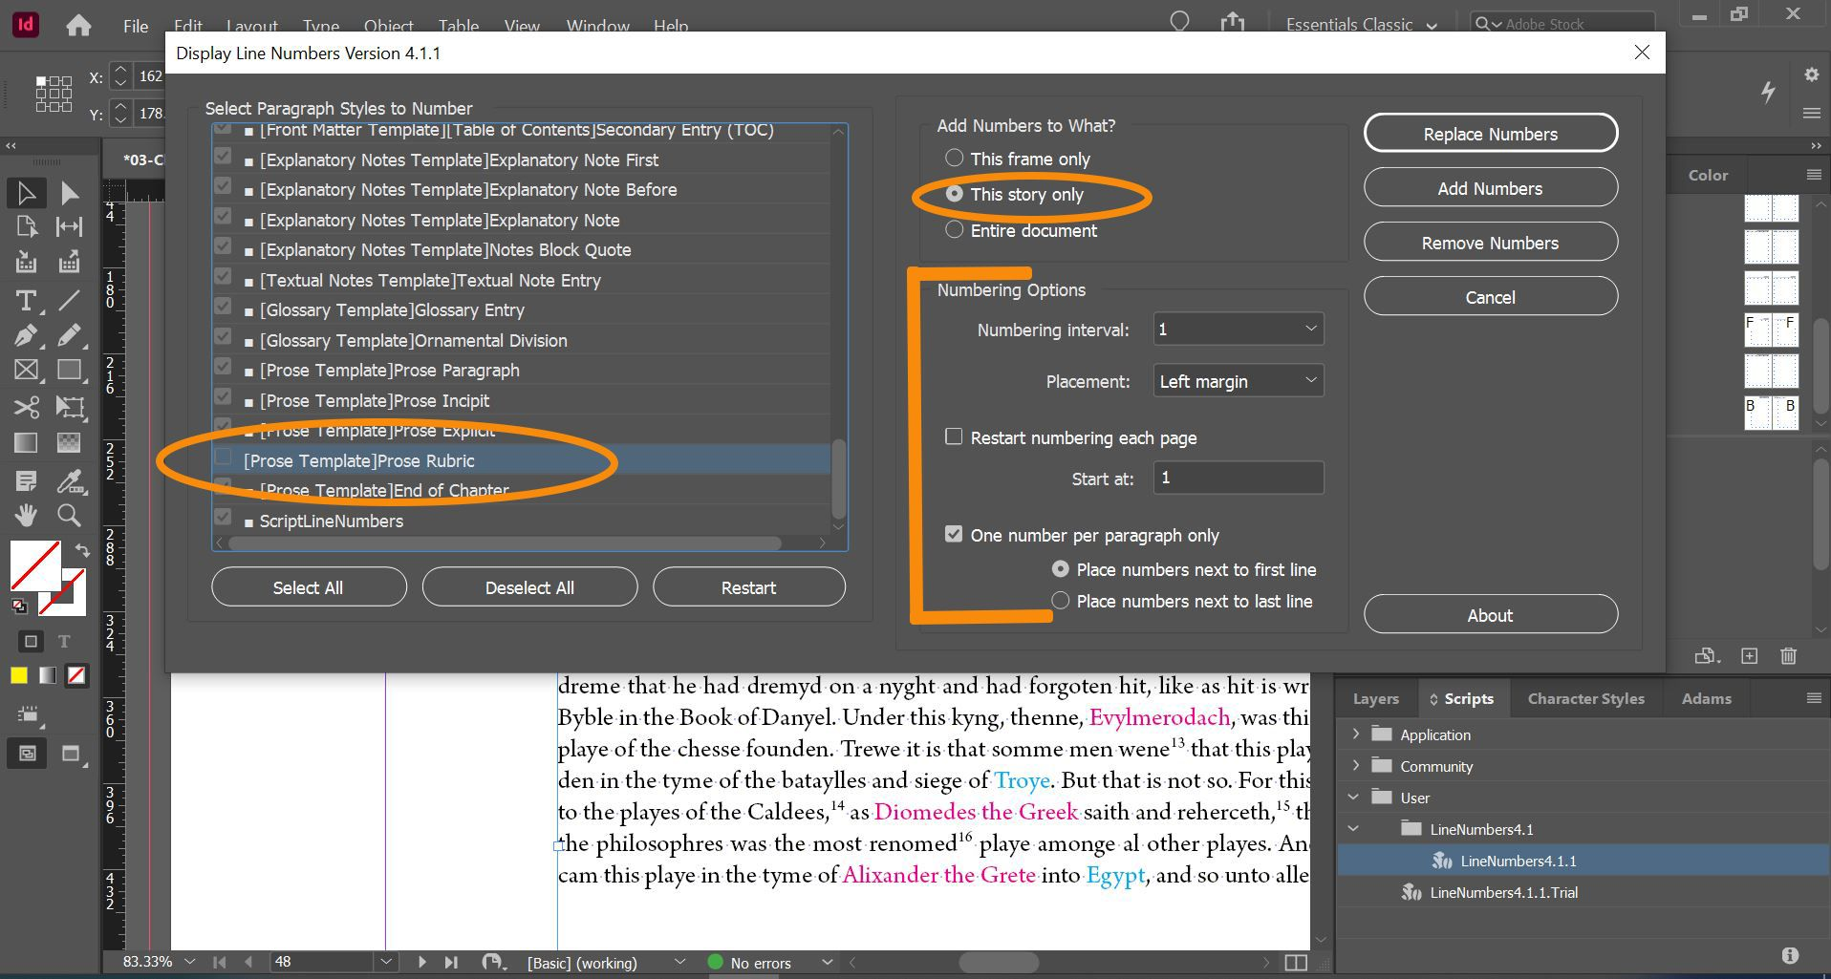

The plugin will automatically create a new text frame on a new Layer along the left margin of the story you have selected and autofill it with numbers alongside each paragraph.

* The Layer is initially locked when the plugin creates it; clicking the lock symbol will unlock the layer and allow you to edit the text.
* The numbers will be colored red and overridden, with a new Paragraph Style **ScriptLineNumbers** applied.
* We’ll edit these later, once all the paragraph numbers have been added to the InDesign document.

This is a sample of what it will look like after you have used the LineNumbers plugin:

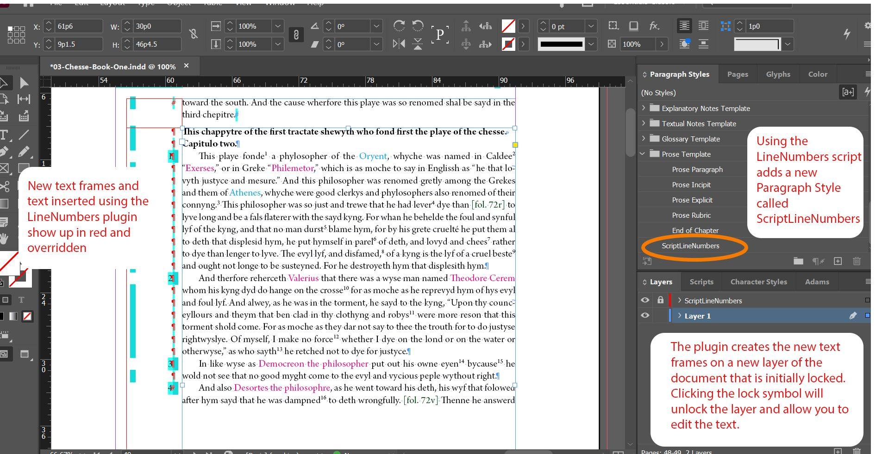

This plugin is very effective, but it is not a subtle tool. It includes options to Remove or Replace numbers, but these options tend to delete all text frames with numbering on a particular spread, instead of only targeting text frames with numbering attached to a particular Story.

* This is one of the reasons we don’t add paragraph numbers to Print Production InDesign files until all the chapters have been formatted, as the chapter layouts should be stable by then.

If paragraph numbers have to be adjusted, there are two techniques:

1. **The Scorched Earth Approach**: Delete all the paragraph numbers from the entire document and start again.
   1. Add Numbers to What? > Entire document > Click Remove Numbers.

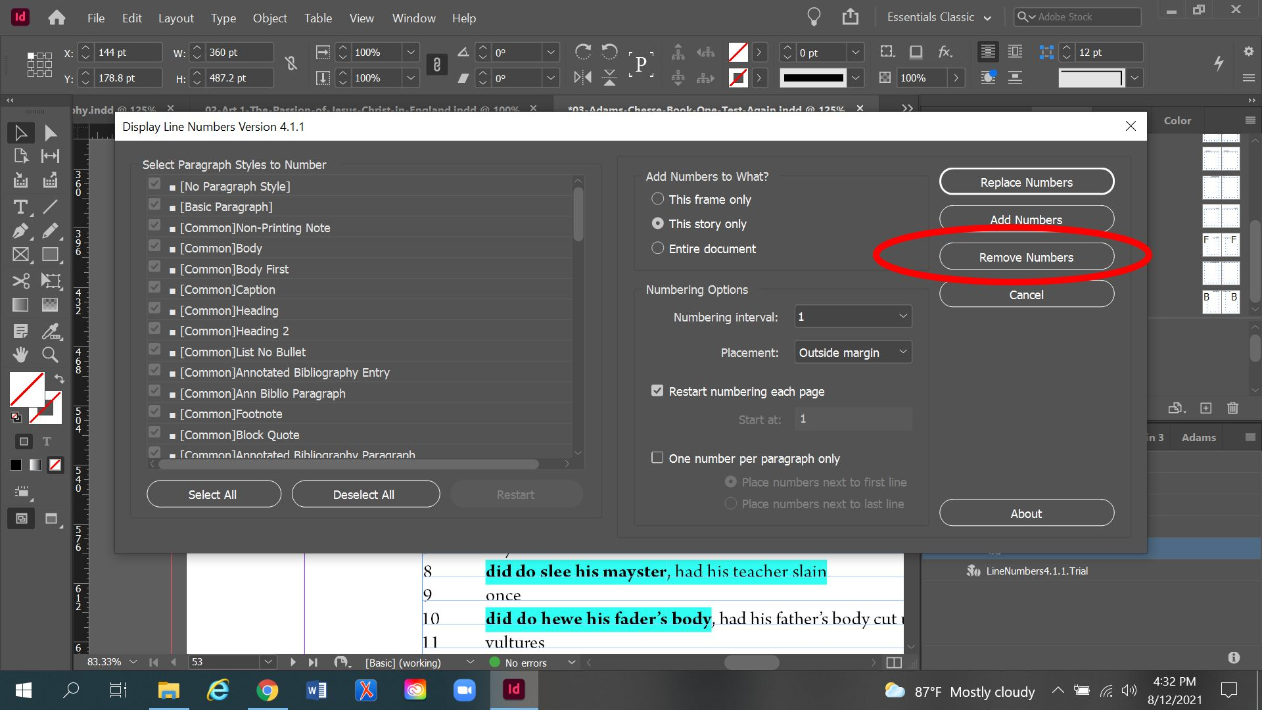

* 1. Then begin adding paragraph numbers using the plugin one chapter at a time, as described above.
  2. This creates more duplicated work than preferred, but it’s often easier than negotiating overlaps in paragraph number applications for different chapters.

1. **The Targeted Approach**: Unlock the ScriptLineNumbers Layer and manually add / adjust whatever numbering or spacing is required.
   1. Open Layers panel > Click the lock symbol next to the ScriptLineNumbersLayer
   2. Then double-click into the text frame with the incorrect paragraph numbers and add / delete end of paragraph marks and add / change / delete paragraph numbers as needed.
   3. This is much more finicky work, so only use this approach if there are only a few paragraph numbers that need adjusting in an isolated instance.

## Final Steps: Editing ScriptLineNumbers Paragraph Style

Once all the paragraph numbers have been added to the document, you will want to edit ScriptLineNumbers Paragraph Style to remove the red character color.

* Right click on the **ScriptLineNumbers** Paragraph Style > Edit “ScriptLineNumbers”
* Character Color: Black
* Click Ok.

This will turn all the paragraph numbers Black instead of Red. They will still be overridden. This is okay; we don’t want to clear these overrides because that will mess with the spacing and potentially unalign the paragraph numbers with their respective paragraphs.

# Final Pagination Adjustment before Moving on to the next Text

First, make sure that the hashtag that indicates the end of the text appears after the final punctuation on the page. Pagination should be more or less set before you move onto a new document. See the Completing a Text Frame section and the Document Pagination section of the Formatting Reference for more details.